Flow Cytometry FACILITY
IGBMC - CNRS UMR7104- Inserm U964
Parc d’Innovation 1,rue Laurent FRIES – F-67404 ILLKIRCH-FRANCE
Tél +33(0)3 88 65 34 28
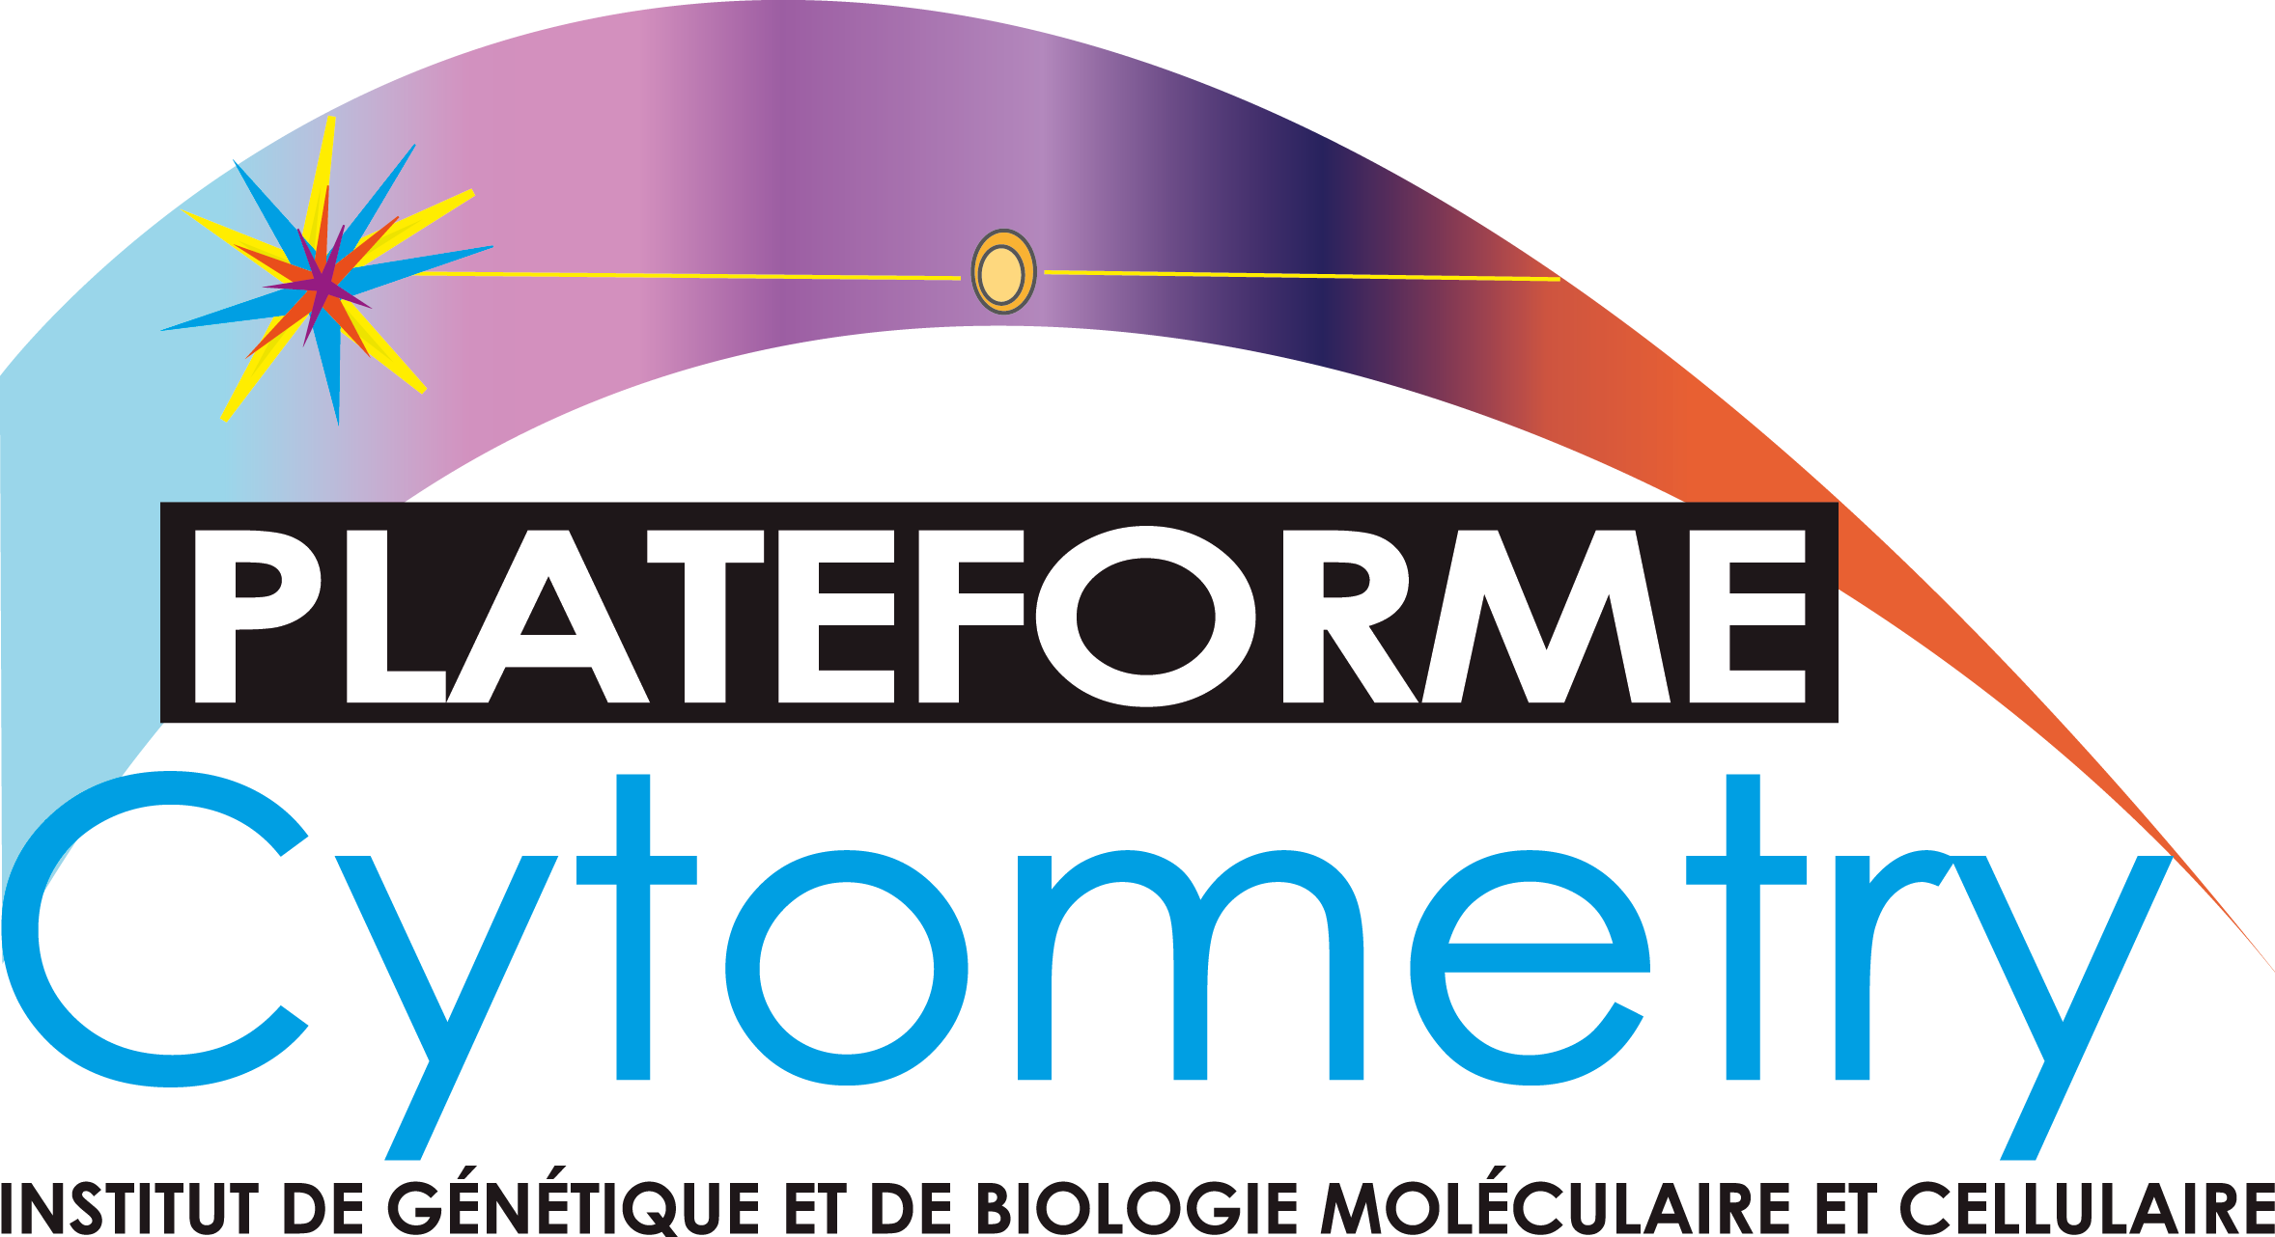
Service Request
REQUESTOR INFORMATION

Name: First Name:
Institution :
Principal Investigator:
E-mail :
PROJECT INFORMATION

Describe briefly your project (100 words)

SAMPLE DESCRIPTION

Species: Mouse Human other (specify)
Type: Culture Cells Line Tissue Type
Blood Others
Staining: Number of Fluorochromes
REQUESTED SERVICE

Analysis Cell Sorting: Tube sort Cloning

